**Voltage Divider Bias Circuit**

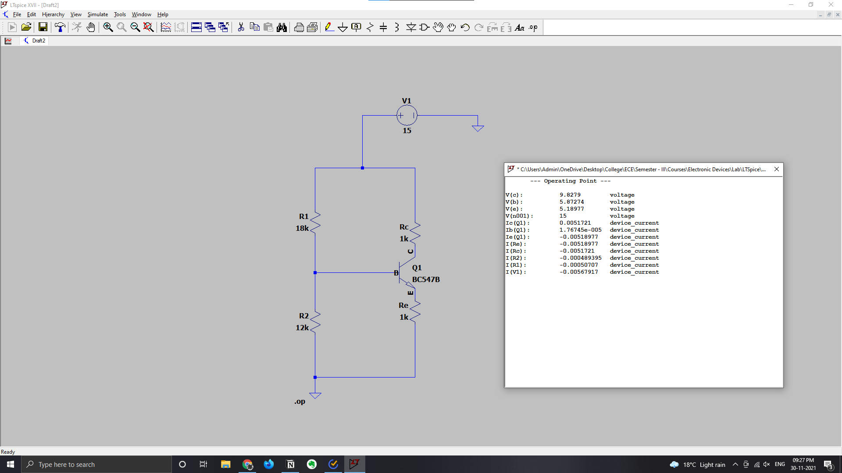

**Fixed Bias Circuit**

